AI-100 Midterm Project

Rymer Popovich, Jake Willingham, Noah Sapper

Restaurant Reviews Using NLP
Our project utilizes natural language processing to determine whether a user review of a restaurant is a positive or negative review.

Data: The dataset we used for training our model was found on Kaggle. It contains 2 attributes with 977 records of data. These attributes simply consist of the review itself and whether that review is considered a positive or negative review (1 or 0).

Data Preprocessing: We first checked the data for any null values, which returned as 0. So we then split the data on a 70/20/10 train, test, validation split. Once split, we were able to tokenize the data using the DistilBERT tokenizer which was already pre-trained.

Model Implementation: After tokenizing the data from all three datasets, we defined the model that we would be using. From the transformers library, we defined the DistilBertForSequenceClassification classifier. In terms of training and fine-tuning the model, we simply created a new dataset including the encodings and labeling from the tokenized data. From the torch library, we implemented the AdamW optimizer to weigh the model. Finally, by using 3 epochs for training, we were able to return a train loss on the third epoch of about 0.05 and a validation loss of about 0.25 to ensure there was no overfitting.

Model Evaluation: After the model had completed its training, we evaluated the performance metrics (Accuracy, Precision, Recall, F1). They were as follows:

Accuracy | 0.92
Precision | 0.96
Recall | 0.8889
F1 | 0.9231

Results Dashboard:
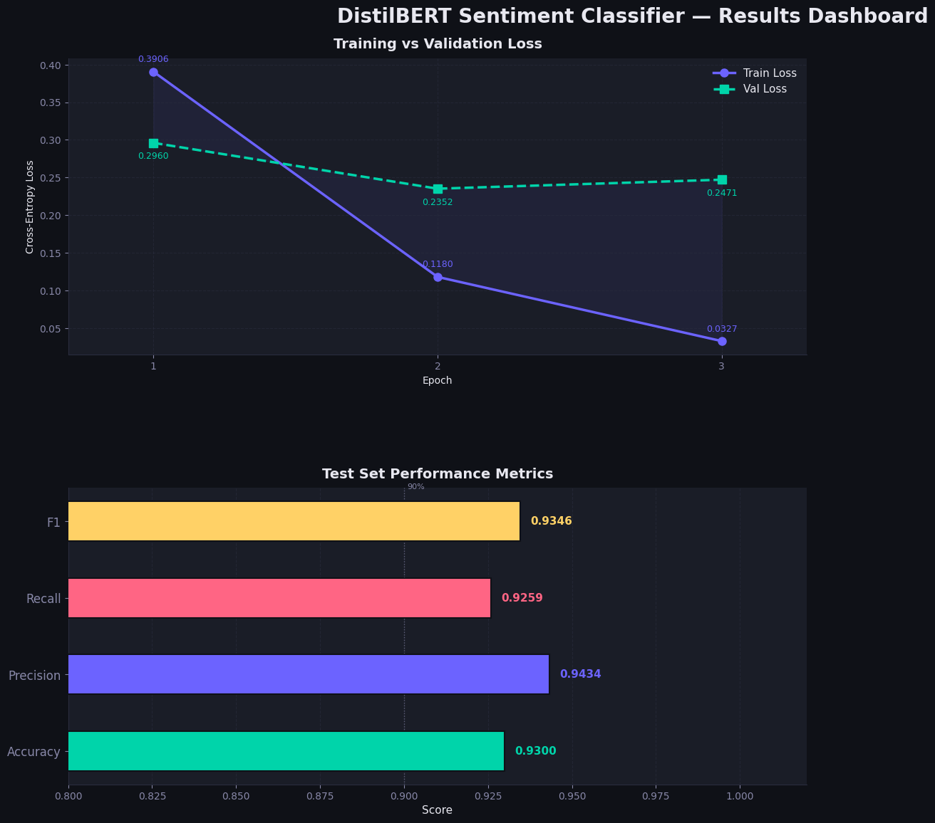

Lessons & Experiences:

The first lesson and roadblock we encountered was tokenizing the data. This meant converting the text from sentence form into more processable units like words which are called tokens. This was done using DistilBERT’s pretrained WordPiece tokenizer. The pretraining provides vocabulary, as well as rules for tokenization like lowercasing, adding special classification and separator tokens, and mapping the tokens to numerical IDs.

Later, during fine tuning, we kept track of both training loss and validation loss. After some research, we learned that the training loss measures how well the model fits the training data and the validation loss evaluates the unseen data and can be used to indicate if the model can be generalized. After three epochs, the training loss decreased substantially from 0.44 to 0.05, while the validation loss only dropped from 0.26 to 0.25. That told us that at that point in the process, the model continued to fit the training data better but could not make improvements in generalization and indicated signs of overfitting. This seems to be expected, and the evaluations were still strong.

